**Database Management System**

**(Lab Task No 05)**



Session (2022-2026)

Program/Class

**BS-Computer Science / 5rd Section-A**

Submitted By:

Student Name : Shahan Khan Roll Number: 301-221008

Supervised By:

Ms. Muneeba Darwaish

Lecturer

CS& IT Department

**Hazara University, Mansehra**

**Showing Table:**

My database table setup looks like this

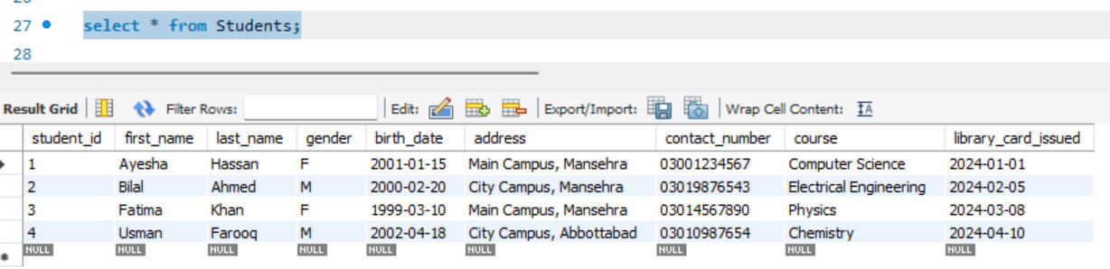

**Using OR Query:**

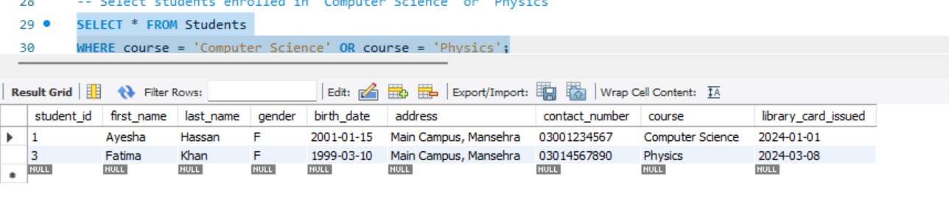

**Using ‘AND’ Query:**

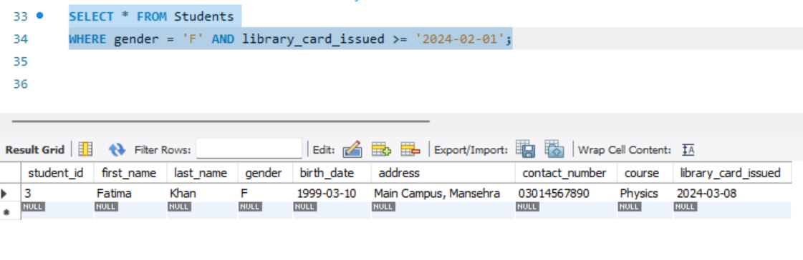

**Using UPDATE Query:**

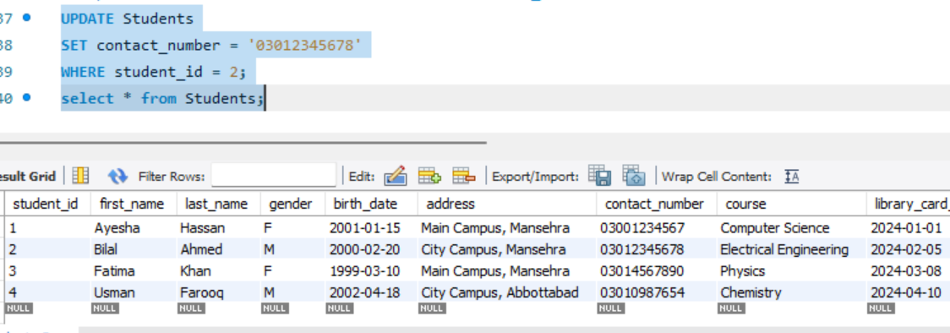

**Using Delete Query:**

